SINCE 1976
901 New York Avenue NW Washington DC 20001 ● Wed-Fri 11-6 Sat-Sun 12-5 ● 202-347-3787 ● @touchstonewdc
www.touchstonegallery.com ● info@touchstonegallery.com
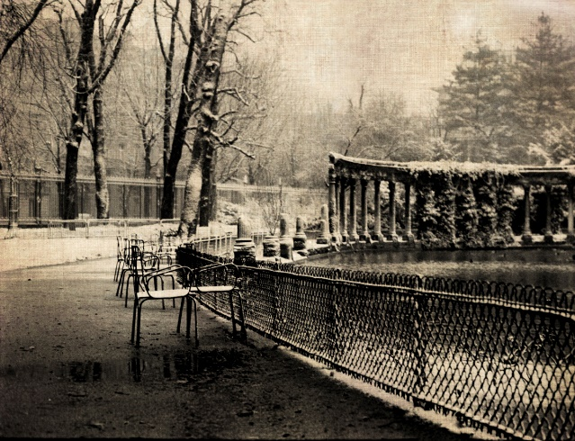
FOR IMMEDIATE RELEASE

January 4 – 28, 2018

MOSAIC: moments & methods
Photography by BD Richardson

Opening Reception: Sunday, January 7, 2018 2 – 4 pm

Mosaic: moments & methods. The images in this body of work represent many decades and moods of a life behind the camera lens. The work features several continents, from Paris to Peru to Poolesville, depicting the iconic as well as the everyday.

But life’s moments are far more vivid than a fading photograph in an old album. These moments are what make up our lives. And thanks to today’s new photographic methods, vintage images are having a renaissance. Old Kodachrome slides, black & white film (and even Instamatic film!) can be digitally re-mastered and re-interpreted. The new “digital darkroom” knows no bounds in harnessing the traditions of the past with the latest technology.

Salt prints—a photo staple of the mid-1800s using sodium chloride and traditional darkroom methods can now be re-created from digital negatives. New-age “tintypes” can be made from images hand-printed onto film and then transferred by hand to aged metal plates. Then there are the sleek acrylic images printed on metallic paper sandwiched between high-grade Plexiglas and aluminum. The choices and methods used are just a small part of linking the rich photographic techniques of the past with today’s digital world.

BD Richardson’s works have won national and international awards. Born in Washington, D.C., she attended George Washington University (B.A.) and American University (M.A.). Marrying an Army officer, life took her to live in Paris and West Point, NY, for several years before returning to Montgomery County (MD) to start a business and family. It was at the U.S. Embassy in Paris in the early 1980s where she had her first photography exhibit. Her photographs have also appeared in various books and national magazines.

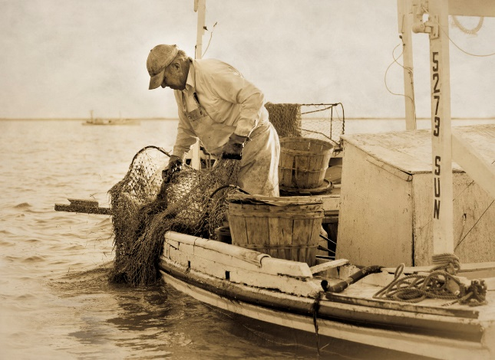
An avid photographer since college, Richardson began experimenting several years ago with breathing new life into her thousands of old fading slides and long-neglected negatives by scanning them into digital files. From there, the possibilities only grew--from alternative processing methods such as printing images onto film and transferring them by hand onto aged metal plates to re-creating actual digital negatives which can be used in a traditional darkroom (yes, complete with UV light, chemicals and a sink!) to create salt and albumen prints. Her work is also available on high-grade acrylic, fine art papers, canvas and wood.

Images: Chairs in Parc Monceau and Working the Water

Please see the gallery’s website www.touchstonegallery.com for additional information, or call 202-347-2787.

